CHAPTER ONE
GENERATION OF ELECTRICAL ENERGY

  - Overview
Electricity flows through wires to light our lamps, run TVs, computers and all other electrical appliances. But where does the electricity come from?
Generation is converting other forms of power into electrical power. This chapter represents an introduction about power system generation which is dividing into thermal power that uses coal and natural gas, hydropower, nuclear power, solar power, and wind power.

1.2 Thermal Generation Station
Thermal generation station produce electricity from the heat released by the combustion of the coal oil, and gas .most station have rating between 200 MW and 1500MW so as to attain the high efficiency and economy of a large installation. Such a station has to be seen to appreciate its enormous complexity and size [1].
Thermal stations are usually located near a river or a lake because large quantities of cooling water are needed to condense the steam as it exhausts from the turbines. The efficiency of a thermal generation station is always low because of the inherent low efficiency of the turbines figure 1.1 shows one of the generation station.

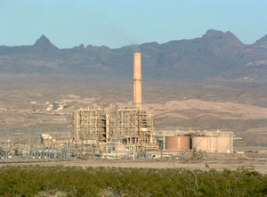
Figure 1.1 Thermal Generation Station [2].

1.2.1 Makeup of Thermal Generation Station
The basic structure and principal components of a thermal generating station are showing in figure 1.2. They are itemized and described below [1].

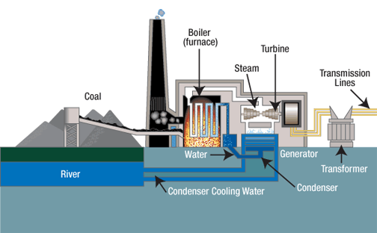

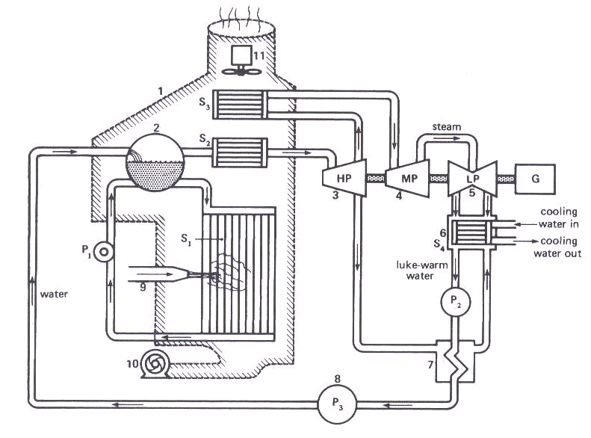Figure 1.2 Basic Components of Thermal Power Plant [3, 1]
- A huge boiler (1) acts as a furnace, transferring water tubes S1, which entirely surround the flames. Water kept circulating through the tubes by pump P1.
- A drum (2) containing water and steam under high pressure produces the steam required by the turbines. It also receives the water delivered by boiler-feed pump P3. Steam races toward the high pressure turbines HP after having passed through super heater S2. The super heater, composed of a series of tubes surrounding the flames, raises the steam temperature ensures that the steam is absolutely dry and raises the overall efficiency of the station.
- The medium-pressure (MP) turbine (4) is similar to the high-pressure turbines, except that is bigger so that the steam may expand still more.
- The low-pressure (LP) turbine (5) is composed of two identical left-hand and right-hand sections remove the remaining available energy from the steam. The steam flowing out of LP expands into an almost perfect vacuum created by the condenser (6).
- Condenser (6) causes the steam to condense by letting it flow over cooling pipes S4.Cold water from an outside source, such as river or lake, flows through the pipes, thus carrying away the heat. It is the condensing steam that creates the vacuum. A condensate pump P2 removes the lukewarm condensed steam and drives it through a re heater (7) toward a feed water pump (8).
- The re-heater (7) is a heat exchanger. It receives hot steam, bled off from high-pressure turbines HP, to raise the temperature of the feed water. Thermodynamic studies show that the overall thermal efficiency is improved when some steam is bled off this way, rather than letting it follow its normal course through all three turbines.
- The burners (9) supply and control the amount of gas, oil, or coal injected. Similarly, heavy bunker oil is preheated and injected as an atomized jet to improve surface contact (and combustion) with surrounding air.
- A forced-draft fan (10) furnishes the enormous quantities of air needed for combustion.
- An indicated-draft fan (11) carries the gases and other products of combustion towards cleansing apparatus and from there to the stack and the out side air.

- Generator G, directly coupled to all three turbines, convert the mechanical energy to electrical energy.
In practice, a steam station has hundred of other components and accessories to ensure high efficiency, safety, and economy. For example, control valves regulate the amount of steam flowing to the turbines; complex water purifies maintain the required cleanliness and chemical composition of the feed water; oil pumps keep the bearings properly lubricated.

1.2.2 Turbines
The low, medium, and high pressure turbines possess a series of blades mounted on the drive shaft figure 1.3. The steam is deflected by the blades; producing a powerful torque. The blades are made of special steel to withstand the high temperature and intense centrifugal forces [1].

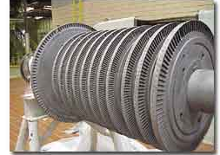
Figure 1.3 Turbine Blades [4].

The low, medium, and high pressure turbines are coupled together to drive a common generator .however ,in some large installation the high pressure turbine drives one generator while the medium pressure and low pressure turbines drive an other one having the same rating .

1.2.3 Condenser
One half of energy produced in the boiler has to be removed from the steam when it exhausts into the condenser. Consequently, enormous quantities of cooling water are needed to carry away the heat.
The temperature of the cooling water increases typically by 5C to 10C as it flow through the condenser tubes. The condensed steam (condensate) usually has temperature between 27C and 33C can the corresponding absolute pressure is a near vacuum of about 5KPa. The cooling water temperature is only a few degrees below the condensate temperature figure 1.4 [1].
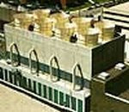
Figure 1.4 The Condenser [2].

1.2.4 Cooling Towers
If the thermal station is located in a dray region, or far a way from a river or a lake, we still have to cool the condenser, one way or another. So it’s often using evaporation to produce the cooling effect but how evaporation can be produced? All that is needed is to expose a large surface of water to the surrounding air. The simplest way to do this is to break up water into small droplets and blow air through this artificial rain.
In the case of a thermal station the warm cooling water flowing out of the condenser is piped to thee top of a cooling tower (figure 1.5), where it is broken up into small droplets. As the droplets fall toward the open reservoir below, evaporation takes place and the droplets are chilled.
The cool water is pumped from the reservoir and re-circulated through the condenser where it again removes heat from the condensing steam .The cycle then repeats. Approximately 2 % of the cooling water the flows through the condenser are lost by evaporation. This loss can be made up by a stream or small lake.
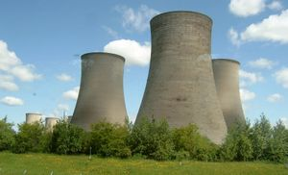
Figure 1.5 Cooling Towers [5].

1.2.5 Boiler Feed Pump
The boiler feed pump drives the feed water into the high-pressure drum. The high back pressure together with the large volume of water flowing through the pump requires a very powerful motor to drive it. In modern steam station the pumping power represents about 1 presents of the generator output.
Although this appears to be a significant loss, the energy expended in the pump is later recovered when the high pressure steam flows through the turbines. Consequently the energy supplied to the feed pump motor is not really lost except for the small portion consumed by the losses in the motor and pump [1].

1.2.6 Energy Flow Diagram for a Steam Plant
Modern thermal generation stations are very similar throughout the world because all designers strive for high efficiency at lowest cost. This means that materials are strained to the limits of the safety as far as temperature, pressure, and centrifugal forces are concerned. Because the same materials are available to all, the resulting steam plants are necessarily similar. Figure 1.6 shows as typical turbine generator.
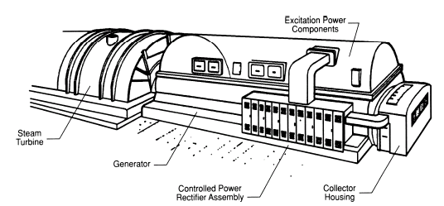
Figure 1.6 Steam Turbine Generator [6].

Most modern boilers furnish steam at a temperature of 550C a pressure of 16.50 MPa. The overall efficiency (electrical output/thermal input) is then about 40 percent. The relative amounts of energy, steam flow, losses, and so forth, don’t change very much provided the temperature and pressure have the approximate values indicated above [1].

1.2.7 Thermal Station and the Environment
The products of combustion of thermal generating station are an increasing subject concern, due their impact on the environment. Carbon dioxide (CO2), sulfur dioxide (SO2), and water are the main products of combustion when oil, coal, or gas, are burned. Carbon dioxide and water produce no immediate environment effects but sulfur dioxide creates substance that give rise to acid rain. Dust and fly ash are other pollutants that may reach the atmosphere. Natural gas produces only water and (CO2). This explains why gas is used (rather than coal or oil), when atmosphere must be reduced to a minimum [1].

1.3 Hydropower Generation
Harnesses the energy of moving or falling water, this is usually in the form of hydroelectricity (water power) from a dam, but it can be used directly as a mechanical force. The term refers to a number of systems in which flowing water drives a hydraulic turbine or waterwheel [7].

1.3.1 Hydroelectricity
Hydroelectricity is obtained from hydropower. Most hydroelectric power comes from the potential energy of dammed water driving a water turbine and generator shows in Figure 1.7. Less common variations make use of water's kinetic energy or undimmed sources such as tidal power. Hydroelectricity is a renewable energy source.
The energy extracted from water depends not only on the volume but on the difference in height between the source and the water's outflow. This height difference is called the head. The amount of potential energy in water is directly proportional to the head. To obtain very high head, water for a hydraulic turbine may be run through a large pipe called a penstock [8].

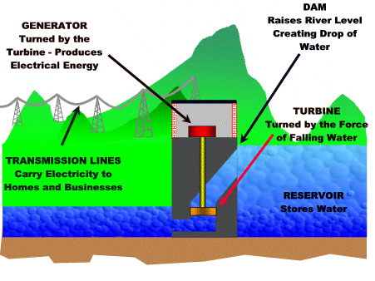
Figure 1.7 Example of Hydropower Plant [9].

1.3.2 How Hydropower Works
Hydropower converts the energy in flowing water into electricity. The quantity of electricity generated is determined by the volume of water flow and the amount of head (the height from turbines in the power plant to the water surface) created by the dam. The greater the flow and head, the more electricity produced.
A typical hydropower plant includes a dam, reservoir, penstocks (pipes), a powerhouse and an electrical power substation. The dam stores water and creates the head; penstocks carry water from the reservoir to turbines inside the powerhouse; the water rotates the turbines, which drive generators that produce electricity.
The electricity is then transmitted to a substation where transformers increase voltage to allow transmission to homes, businesses and factories [10].

1.3.3 Types of Hydropower Plants
Hydropower plants are divided into two main parts which are Conventional and Pumped Storage.

1.3.3.1 Conventional
Most hydropower plants are conventional in design, meaning they use one-way water flow to generate electricity. There are two categories of conventional plants, run of river and storage plants [10].
- Run-of-river plants these plants use little, if any, stored water to provide water flow through the turbines. Although some plants store a day or week's worth of water, weather changes especially seasonal changes cause run of river plants to experience significant fluctuations in power output.
- Storage plants these plants have enough storage capacity to offset seasonal fluctuations in water flow and provide a constant supply of electricity throughout the year. Large dams can store several years’ worth of water.

1.3.3.2 Pumped Storage
In contrast to conventional hydropower plants, pumped storage plants reuse water. After water initially produces electricity, it flows from the turbines into a lower reservoir located below the dam. During off-peak hours (periods of low energy demand), some of the water is pumped into an upper reservoir and reused during periods of peak-demand [10].

1.3.4 Advantages and Disadvantages of Hydropower Energy
The advantages and disadvantages of Hydropower plants are very important to the countries which have good resources of waters some of this advantages and disadvantages are listed below.

1.3.4.1 Advantages
The major advantage of hydro systems is elimination of the cost of fuel. Hydroelectric plants are immune to price increases for fossil fuels such as oil, natural gas or coal, and do not require imported fuel.
Hydroelectric plants tend to have longer lives than fuel-fired generation, with some plants now in service having been built 50 to 100 years ago. Labor cost also tends to be low since plants are generally heavily automated and have few personnel on site during normal operation.
Pumped storage plants currently provide the most significant means of storage of energy on a scale useful for a utility, allowing low-value generation in off-peak times (which occurs because fossil-fuel plants cannot be entirely shut down on a daily basis) to be used to store water that can be released during high load daily peaks. Operation of pumped-storage plants improves the daily load factor of the generation system.
Reservoirs created by hydroelectric schemes often provide excellent leisure facilities for water sports, and become tourist attractions in themselves. Multi use dams installed for irrigation, flood control, or recreation, may have a hydroelectric plant added with relatively low construction cost, providing a useful revenue stream to offset the cost of dam operation [8].

1.3.4.2 Disadvantages
In practice, the utilization of stored water is sometimes complicated by demand for irrigation which may occur out of phase with peak electricity demand. Times of drought can cause severe problems, since water replenishment rates may not keep up with desired usage rates. Minimum discharge requirements represent an efficiency loss for the station if it is uneconomic to install a small turbine unit for that flow.
Concerns have been raised by environmentalists that large hydroelectric projects might be disruptive to surrounding aquatic ecosystems. For instance, studies have shown that dams along the Atlantic and Pacific coasts of North America have reduced salmon populations by preventing access to spawning grounds upstream, even though most dams in salmon habitat have fish ladders installed. Salmon are also harmed on their migration to sea when they must pass through turbines. Turbine and power-plant designs that are easier on aquatic life are an active area of research.
Generation of hydroelectric power can also have an impact on the downstream river environment. First, water exiting a turbine usually contains very little suspended sediment, which can lead to scouring of river beds and loss of riverbanks. Second, since turbines are often opened intermittently, rapid or even daily fluctuations in river flow are observed. In the Grand Canyon, the daily cyclic flow variation caused by Glen Canyon Dam was found to be contributing to erosion of sand bars.
Dissolved oxygen content of the water may change from preceding conditions. Finally, water exiting from turbines is typically much colder than the pre-dam water, which can change aquatic faunal populations, including endangered species.
The reservoirs of hydroelectric power plants in tropical regions may produce substantial amounts of methane and carbon dioxide. This is due to plant material in newly flooded and re-flooded areas being inundated with water, decaying in an aerobic environment, and forming methane, a very potent greenhouse gas. The methane is released into the atmosphere once the water is discharged from the dam and turns the turbines.
Another disadvantage of hydroelectric dams is the need to relocate the people living where the reservoirs are planned. In many cases, no amount of compensation can replace ancestral and cultural attachments to places that have spiritual value to the displaced population. Additionally, historically and culturally important sites can be flooded and lost [8].

1.4 Nuclear Power Generation
Nuclear power is the controlled use of nuclear reactions to release energy for work including propulsion, heat, and the generation of electricity. Human use of nuclear power to do significant useful work is currently limited to nuclear fission and radioactive decay. Nuclear energy is produced when a fissile material, such as uranium 235 (${}^{\text{235}}U$), is concentrated such that nuclear fission takes place in a controlled chain reaction and creates heat which is used to boil water, produce steam, and drive a steam turbine[11].
The turbine can be used for mechanical work and also to generate electricity. Nuclear power is used to power most military submarines and aircraft carriers and provides 7% of the world's energy and 17% of the world's electricity.
The use of nuclear power is controversial because of the problem of storing radioactive waste for indefinite periods, the potential for possibly severe radioactive contamination by accident or sabotage, and the possibility that its use in some countries could lead to the proliferation of nuclear weapons. These risks are small and can be further reduced by the technology in the new reactors. They further claim that the safety record is already good when compared to other fossil-fuel plants that it releases much less radioactive waste than coal power, and that nuclear power is a sustainable energy source.
Nuclear power is an uneconomic, unsound and potentially dangerous energy source, especially compared to renewable energy, and dispute whether the costs and risks can be reduced through new technology [11].

1.4.1 Nuclear Fission
Also known as atomic fission is a process in nuclear physics in which the nucleus of an atom splits into two or more smaller nuclei as fission products, and usually some by product particles. Hence, fission is a form of elemental transmutation. The by products include free neutrons, photons usually in the form gamma rays, and other nuclear fragments such as beta particles and alpha particles [12].
Fission of heavy elements is an exothermic reaction and can release substantial amounts of useful energy both as gamma rays and as kinetic energy of the fragments (heating the bulk material where fission takes place).
Nuclear fission is used to produce energy for nuclear power and to drive explosion of nuclear weapons. Fission is useful as a power source because some materials, called nuclear fuels, both generate neutrons as part of the fission process and also undergo triggered fission when impacted by a free neutron. Nuclear fuels can be part of a self-sustaining chain reaction that releases energy at a controlled rate in a nuclear reactor or at a very rapid uncontrolled rate in a nuclear weapon.
The amount of free energy contained in nuclear fuel is millions of times the amount of free energy contained in a similar mass of chemical fuel such as gasoline, making nuclear fission a very tempting source of energy; however, the waste products of nuclear fission are highly radioactive and remain so for millennia, giving rise to a nuclear waste problem. Concerns over nuclear waste accumulation and over the immense destructive potential of nuclear weapons counterbalance the desirable qualities of fission as an energy source, and give rise to intense ongoing political debate over nuclear power [12].

1.4.2 Chain Reactions
How the fission of a uranium atom can be provoked? One way is to bombard its nucleus with neutrons. A neutron makes an excellent projectile because it is not repelled as it approaches the nucleus and, if its speed is too great, it has a good chance of scoring a hit. If the impact is strong enough, the nucleus will split in two, releasing energy [1].
The fission of one atom of ${}^{\text{235}}U$ releases 218 MeV of energy, mainly in the form of heat. Fission is a very violent reaction on an atomic scale, and it produces a second important effect: It ejects 2 or 3 neutrons that move at high speed away from the broken nucleus. These neutrons collide with other uranium atoms, breaking them up, and a chain reaction quickly takes place, releasing a tremendous amount of heat. This is the principle that causes atomic bombs to explode. Although a uranium mine also releases neutrons the concentration of ${}^{\text{235}}U$ atom is too low to produce a chain reaction.
In the case of a nuclear reactor, the neutrons must be slow down to increase their chance of striking other uranium nuclei. Toward this end, small fissionable masses of uranium fuel (${\text{UO}}_{2}$) are immersed in a moderator. The moderator may be ordinary water, heavy water, graphite, or any other material that can slow down neutrons without absorbing them. By using an appropriate geometrical distribution of the uranium fuel within the moderator, the speed of the neutrons can be reduced so they have required velocity to initiate other fusions. Only then will a chain reaction take place, causing the reactor to go critical.
As soon as the chain reaction starts, the temperature rises rapidly through the reactor to carry away the heat. This coolant may be heavy water, ordinary water, liquid sodium, or a gas like helium or carbon dioxide. The hot coolant moves in a closed circuit which includes a heat exchanger. The latter transfers the heat to steam generator that drives the turbine as shown in figure1.8. Thus, contrary to what its name would lead us to believe, the coolant is not cool but searingly hot [1].

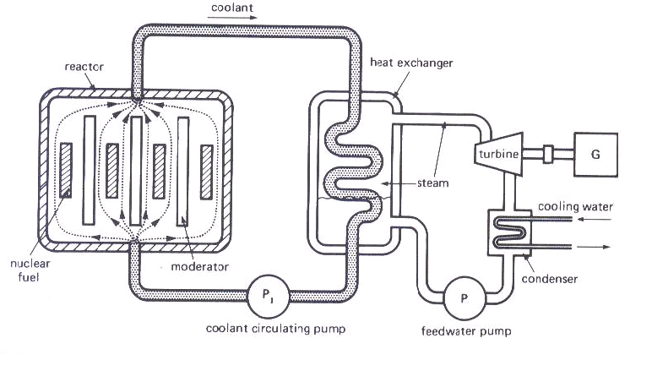
Figure 1.8 Schematic Diagram of a Nuclear Power Station [1].

1.4.3 Reactor Types
The nuclear fission reactor produces heat through a controlled nuclear chain reaction in a critical mass of fissile material. All current nuclear power plants are critical fission reactors, which are the focus of this article. The output of fission reactors is controllable. All reactors will be compared to the Pressurized Water Reactor (PWR), as that is the standard modern reactor design.
In general, fast-spectrum reactors will produce less waste, and the waste they do produce will have a vastly shorter half life, but they are more difficult to build, and more expensive to operate. Fast reactors can also be breeders, whereas thermal reactors generally cannot [11]. There are several subtypes of critical fission reactors:
- Pressurized Water Reactors (PWR)
- Boiling Water Reactors (BWR)
- Pressurized Heavy Water Reactor (PHWR)
- Gas Cooled Reactor (GCR) and Advanced Gas Cooled Reactor (AGCR)
- Super Critical Water-Cooled Reactor (SCWR)
- Liquid Metal Fast Breeder Reactor (LMFBR)

1.5 Wind Power
Wind power is the conversion of wind energy into more useful forms, usually electricity using wind turbines. In 2005, worldwide capacity of wind-powered generators was 58,982 megawatts, their production making up less than 1% of world-wide electricity use [13].

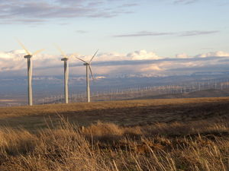
Figure 1.9 Generation of Wind Power [13].
Most modern wind power is generated in the form of electricity by converting the rotation of turbine blades into electrical current by means of an electrical generator. In windmills (a much older technology) wind energy is used to turn mechanical machinery to do physical work, like crushing grain or pumping water.
Wind power is used in large scale wind farms for national electrical grids as well as in small individual turbines for providing electricity in isolated locations.
Wind energy is abundant, renewable, widely distributed, cleans, and mitigates the greenhouse effect if it is used to replace fossil-fuel-derived electricity [13].

1.5.1 How Does a Wind Turbine Work?
Wind is a form of solar energy. Winds are caused by the uneven heating of the atmosphere by the sun, the irregularities of the earth's surface, and rotation of the earth. Wind flow patterns are modified by the earth's terrain, bodies of water, and vegetation. Humans use this wind flow, or motion energy, for many purposes: sailing, flying a kite, and even generating electricity.
The terms wind energy or wind power describes the process by which the wind is used to generate mechanical power or electricity. Wind turbines convert the kinetic energy in the wind into mechanical power. This mechanical power can be used for specific tasks (such as grinding grain or pumping water) or a generator can convert this mechanical power into electricity.
So how do wind turbines make electricity? Simply stated, a wind turbine works the opposite of a fan. Instead of using electricity to make wind, like a fan, wind turbines use wind to make electricity. The wind turns the blades, which spin a shaft, which connects to a generator and makes electricity. This aerial view of a wind power plant shows how a group of wind turbines can make electricity for the utility grid. The electricity is sent through transmission and distribution lines to homes, businesses, schools, and so on [14].

1.5.2 Wind Turbine Constructions
There are various parts inside a wind turbine shown in figure1.10 and it's Glossary into:

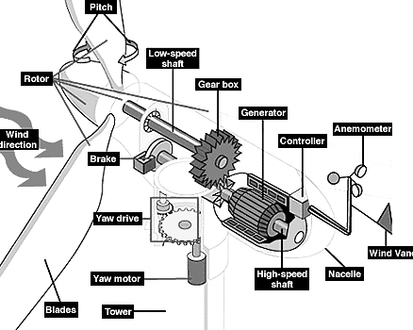
Figure 1.10 Structure Design of Wind Turbine [14].

- Anemometer: Measures the wind speed and transmits wind speed data to the controller.
- Blades: Most turbines have either two or three blades. Wind blowing over the blades causes the blades to lift and rotate.
- Brake: A disc brake, which can be applied mechanically, electrically, or hydraulically to stop the rotor in emergencies.
- Controller: The controller starts up the machine at wind speeds of about 8 to 16 miles per hour (mph) and shuts off the machine at about 65 mph. Turbines cannot operate at wind speeds above about 65 mph because their generators could overheat.
- Gear box: Gears connect the low-speed shaft to the high-speed shaft and increase the rotational speeds from about 30 to 60 rotations per minute (rpm) to about 1200 to 1500 rpm, the rotational speed required by most generators to produce electricity. The gear box is a costly (and heavy) part of the wind turbine and engineers are exploring direct-drive generators that operate at lower rotational speeds and don't need gear boxes.
- Generator: Usually an off-the-shelf induction generator that produces 60-cycle AC electricity.
- High-speed shaft: Drives the generator.
- Low-speed shaft: The rotor turns the low-speed shaft at about 30 to 60 rotations per minute.
- Nacelle: The rotor attaches to the nacelle, which sits atop the tower and includes the gear box, low- and high-speed shafts, generator, controller, and brake. A cover protects the components inside the nacelle. Some nacelles are large enough for a technician to stand inside while working.
- Pitch: Blades are turned, or pitched, out of the wind to keep the rotor from turning in winds that are too high or too low to produce electricity.
- Rotor: The blades and the hub together are called the rotor.
- Tower: Towers are made from tubular steel or steel lattice. Because wind speed increases with height, taller towers enable turbines to capture more energy and generate more electricity.
- Wind direction: This is an upwind turbine, so-called because it operates facing into the wind. Other turbines are designed to run downwind, facing away from the wind.
- Wind vane: Measures wind direction and communicates with the yaw drive to orient the turbine properly with respect to the wind.
- Yaw drive and yaw motor: Upwind turbines face into the wind; the yaw drive is used to keep the rotor facing into the wind as the wind direction changes. Downwind turbines don't require a yaw drive; the wind blows the rotor downwind. And yaw motor power the yaw drive [14].

1.5.3 Advantages and Disadvantages of Wind Energy
Wind energy is one of the environments basics so the advantages and disadvantages are [15]:

1.5.3.1 Advantages
- Wind energy is fueled by the wind, so it's a clean fuel source. Wind energy doesn't pollute the air like power plants that rely on combustion of fossil fuels, such as coal or natural gas. Wind turbines don't produce atmospheric emissions that cause acid rain or greenhouse gasses.
- Wind energy is a domestic source of energy, produced in the United States. The nation's wind supply is abundant.
- Wind energy relies on the renewable power of the wind, which can't be used up. Wind is actually a form of solar energy; winds are caused by the heating of the atmosphere by the sun, the rotation of the earth, and the earth's surface irregularities.
- Wind energy is one of the lowest-priced renewable energy technologies available today, costing between 4 and 6 cents per kilowatt-hour, depending upon the wind resource and project financing of the particular project.
- Wind turbines can be built on farms or ranches, thus benefiting the economy in rural areas, where most of the best wind sites are found. Farmers and ranchers can continue to work the land because the wind turbines use only a fraction of the land. Wind power plant owners make rent payments to the farmer or rancher for the use of the land [15].

1.5.3.2 Disadvantages
- Wind power must compete with conventional generation sources on a cost basis. Depending on how energetic a wind site is, the wind farm may or may not be cost competitive. Even though the cost of wind power has decreased dramatically in the past 10 years, the technology requires a higher initial investment than fossil-fueled generators.
- The major challenge to using wind as a source of power is that the wind is intermittent and it does not always blow when electricity is needed. Wind energy cannot be stored (unless batteries are used); and not all winds can be harnessed to meet the timing of electricity demands.
- Good wind sites are often located in remote locations, far from cities where the electricity is needed.
- Wind resource development may compete with other uses for the land and those alternative uses may be more highly valued than electricity generation.
- Although wind power plants have relatively little impact on the environment compared to other conventional power plants, there is some concern over the noise produced by the rotor blades, aesthetic (visual) impacts, and sometimes birds have been killed by flying into the rotors. Most of these problems have been resolved or greatly reduced through technological development or by properly sitting wind plants [15].

1.6 Solar Power
Solar power is the technology of obtaining usable energy from the light of the Sun [16].A solar cell (or a photovoltaic cell) is a semiconductor device that converts photons from the sun (solar light) into electricity. In general a solar cell that includes both solar and non-solar sources of light (such as photons from incandescent bulbs) is termed a photovoltaic cell.
Fundamentally, the device needs to fulfill only two functions: photo generation of charge carriers (electrons and holes) in a light-absorbing material, and separation of the charge carriers to a conductive contact that will transmit the electricity. This conversion is called the photovoltaic effect, and the field of research related to solar cells is known as photovoltaic.
Solar cells have many applications. Historically solar cells have been used in situations where electrical power from the grid is unavailable, such as in remote area power systems, Earth orbiting satellites, consumer systems, e.g. handheld calculators or wrist watches, remote radiotelephones and water pumping applications.
Recently solar cells are particularly used in assemblies of solar modules (photovoltaic arrays) connected to the electricity grid through an inverter, often in combination with a net metering arrangement [16].

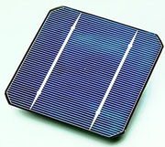
Figure 1.11 Example of Solar Cell [16].

1.6.1 Photovoltaic (or PV)
Photovoltaic, or PV, are a solar power technology that uses solar photovoltaic arrays or solar cells to provide electricity for human activities. Photovoltaics are also the field of study relating to this technology.
Solar cells produce direct current electricity from the sun’s rays, which can be used to power equipment or to recharge a battery. Many pocket calculators incorporate a solar cell.
When more power is required than a single cell can deliver, cells are generally grouped together to form PV modules that may in turn be arranged in solar arrays which are sometimes ambiguously referred to as solar panels. Such solar arrays have been used to power orbiting satellites and other spacecraft and in remote areas as a source of power for applications such as roadside emergency telephones, remote sensing, and cathodic protection of pipelines.
The continual decline of manufacturing costs (dropping at 3 to 5% a year in recent years) is expanding the range of cost-effective uses including road signs, home power generation and even grid-connected electricity generation [17].

1.6.2 Photovoltaic Array
A photovoltaic array is a linked collection of photovoltaic modules. Each photovoltaic (PV) module is made of multiple interconnected PV cells. The cells convert solar energy into direct-current electricity.
PV modules are sometimes called solar panels, although that term better applies to solar-thermal water or air heating panels. Photovoltaic modules distinguish themselves from solar cells in that they are conveniently sized and packaged in weather resistant housings for easy installation and deployment in residential, commercial, and industrial applications. The application and study of photovoltaic devices is known as photovoltaic.
PV cells operate via the photovoltaic effect which describes how certain materials can convert sunlight into electricity; they absorb some of the energy of the Sun and cause current to flow between two oppositely charged layers.
Individual solar cells provide a relatively small amount of power, but electrical output can be significant when connected together. The cells, modules, and arrays can be connected in series or parallel, or typically a combination, to create a desired peak voltage output [18].

1.6.3 Solar Thermal Power Plants
Solar thermal power plants use the sun's rays to heat a fluid, from which heat transfer systems may be used to produce steam. The steam, in turn, is converted into mechanical energy in a turbine and into electricity from a conventional generator coupled to the turbine.
Solar thermal power generation is essentially the same as conventional technologies except that in conventional technologies the energy source is from the stored energy in fossil fuels released by combustion. Solar thermal technologies use concentrator systems due to the high temperatures needed for the working fluid. The three types of solar-thermal power systems in use or under development are: parabolic trough, solar dish, and solar power tower [19].

1.6.3.1 Parabolic Trough
The parabolic trough is used in the largest solar power facility in the world. Parabolic trough collector has a linear parabolic-shaped reflector that focuses the sun's radiation on a linear receiver located at the focus of the parabola.
The collector tracks the sun along one axis from east to west during the day to ensure that the sun is continuously focused on the receiver. Because of its parabolic shape, a trough can focus the sun at 30 to 100 times its normal intensity (concentration ratio) on a receiver pipe located along the focal line of the trough, achieving operating temperatures over 400 degrees Celsius [19].

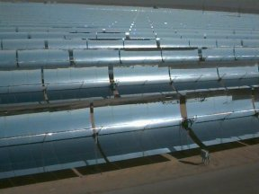
Figure 1.12 Examples of Parabolic Trough Cells [19].

A collector field consists of a large field of single-axis tracking parabolic trough collectors. The solar field is modular in nature and is composed of many parallel rows of solar collectors aligned on a north-south horizontal axis.
A working (heat transfer) fluid is heated as it circulates through the receivers and returns to a series of heat exchangers at a central location where the fluid is used to generate high-pressure superheated steam. The steam is then fed to a conventional steam turbine generator to produce electricity.
After the working fluid passes through the heat exchangers, the cooled fluid is re-circulated through the solar field. The plant is usually designed to operate at full rated power using solar energy alone, given sufficient solar energy. However, all plants are hybrid solar/fossil plants that have a fossil-fired capability that can be used to supplement the solar output during periods of low solar energy. The Luz plant is a natural gas hybrid.

1.6.3.2 Solar Dish
A solar dish engine system utilizes concentrating solar collectors that track the sun on two axes, concentrating the energy at the focal point of the dish because it is always pointed at the sun. The solar dish's concentration ratio is much higher that the solar trough, typically over 2,000, with a working fluid temperature over 750ºC.
The power-generating equipment used with a solar dish can be mounted at the focal point of the dish, making it well suited for remote operations or, as with the solar trough, the energy may be collected from a number of installations and converted to electricity at a central point. The engine in a solar dish/engine system converts heat to mechanical power by compressing the working fluid when it is cold, heating the compressed working fluid, and then expanding the fluid through a turbine or with a piston to produce work. The engine is coupled to an electric generator to convert the mechanical power to electric power [19].

1.6.3.3 Solar Power Tower
A solar power tower or central receiver generates electricity from sunlight by focusing concentrated solar energy on a tower-mounted heat exchanger (receiver). This system uses hundreds to thousands of flat sun-tracking mirrors called heliostats to reflect and concentrate the sun's energy onto a central receiver tower.
The energy can be concentrated as much as 1,500 times that of the energy coming in from the sun. Energy losses from thermal-energy transport are minimized as solar energy is being directly transferred by reflection from the heliostats to a single receiver, rather than being moved through a transfer medium to one central location, as with parabolic troughs. Power towers must be large to be economical. This is a promising technology for large-scale grid-connected power plants. Though power towers are in the early stages of development compared with parabolic trough technology, a number of test facilities have been constructed around the world [19].

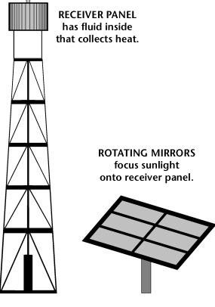
Figure 1.13 Example of Solar Power Tower and Cells [19]
1.6.4 Advantages and Disadvantages of Solar Energy
The main advantages and disadvantages of solar power are:

1.6.4.1 Advantages
- Solar power is pollution free during use. Production end wastes and emissions are manageable using existing pollution controls. Decommissioning and recycling technologies are under development.
- Facilities can operate with little maintenance or intervention after initial setup.
- Solar electric generation is economically competitive where grid connection or fuel transport is difficult, costly or impossible. Examples include satellites, island communities, remote locations and ocean vessels.
- When grid connected, solar electric generation can displace the highest cost electricity during times of peak demand (in most climatic regions), can reduce grid loading, and can eliminate the need for local battery power for use in times of darkness and high local demand; such application is encouraged by net metering[16].

1.6.4.2 Disadvantages
- Limited power density for electrical generation with photovoltaic, the average irradiation power density is approximately 1 kW/m² usable by 8-15% efficient solar panels.
- Intermittency it is not available at night and is reduced when there is cloud cover, decreasing the reliability of peak output performance or requiring a means of energy storage. For power grids to stay functional at all times, the addition of substantial amounts of solar generated electricity would require the expansion of energy storage facilities, other renewable energy sources, or the use of backup conventional power plants. There is an energy cost to keep coal-burning power plants 'hot', which includes the burning of coal to keep boilers at temperature. However, natural gas power plants can quickly come up to full load without requiring significant standby idling. Locations at high latitudes or with frequent substantial cloud cover offer reduced potential for solar power use.
- Like electricity from nuclear or fossil fuel plants, it can only realistically be used to power transport vehicles by converting light energy into another form of energy (e.g. battery stored electricity or by electrolyzing water to produce hydrogen) suitable for transport.
- Solar cells produce DC which must be converted to AC when used in currently existing distribution grids. This incurs an energy penalty of 4-12% [16].

1.7 Summary
This chapter represents generation of electrical energy which is the main part of power system parameters with different types (thermal energy, hedro energy, nuclear emerge, wind energy, and solar emerge).Next chapter deals with the other parts of power system which is transmission and distribution systems.

